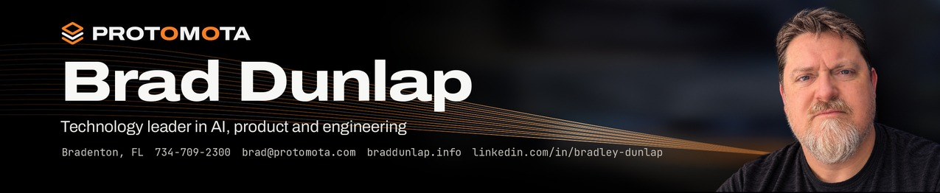
Brad Dunlap Technology leader in AI, product and engineering Bradenton, FL 734-709-2300 brad@protomota.com braddunlap.info linkedin.com/in/bradley-dunlap
1 Summary
Technology leader with 20+ years in software engineering, product ownership and digital product delivery. Leads multidisciplinary teams and connects business priorities to application design, architecture and implementation. At NTT DATA, serves as technical lead and product owner for a Fortune 500 initiative in virtual reality, voice and AI-assisted automation. Independently builds native apps, robots and AI agent systems through Protomota Lab.
Table 1. Key figures
Professional experience | 20+ years
Automotive brand apps led | 7
Shopping center apps directed | 15
Enterprise product team | 20+ people
Overruns during scoping program | 0 projects
Self-published native apps | 2
Self-published websites and web apps | 6
2 Professional experience
NTT DATA
Digital Solution Consultant Associate Director Oct 2023 – Present
Technical Lead and Product Owner Jan 2026 – Present
■ Lead a small multidisciplinary engineering team building VR, voice and AI-assisted automation applications for a Fortune 500 client's confidential workflow initiative, now in pilot.
■ Own backlog, acceptance criteria and release planning; run product demos and define scope with the client.
■ Direct architecture and implementation across Azure, a Next.js web app, a Unity app and supporting automation.
■ Build AI and voice capabilities: speech recognition, text-to-speech, conversational AI and voice commands.
Research and Development in AI and Robotics Simulation Apr 2025 – Dec 2025
■ Trained on NVIDIA Omniverse, Isaac Sim and Isaac Lab; built simulation workflows with ROS 2 connecting hardware behavior and software-driven test environments.
■ Built agentic systems for coordinating AI-assisted technical work, research and delivery workflows.
Product Owner, Enterprise Mobile Application Oct 2023 – Apr 2025
■ Owned a multi-year iOS and Android application for a top U.S. manufacturing company, translating product direction into epics, user stories and acceptance criteria for a 20+ person team in Azure DevOps.
■ Partnered in quarterly SAFe PI Planning on objectives, roadmaps, priorities and cross-team dependencies.
■ Contributed to scoping and estimating a project extension that secured continued development investment.
Protomota Lab
Independent work outside professional employment
Founder and Independent Developer protomota.com
■ Design, build and run Jotley end to end, including the app, release, marketing and website: a native Mac, iPhone and iPad app for real-time transcription, AI summaries, searchable notes and AI chat.
■ Design, build and run PulseCanvas Studio end to end, including the app, release, marketing and website: a native Mac music visualizer and video app in Swift, SwiftUI and Metal, with export up to 4K at 60 fps.
■ Develop AI agents and automate complex workflows end to end, coordinating work with Hermes Agent.
■ Build electronics, assemble and program robots, and run local AI models on personal hardware, including robots.
Vectorform
Director of Scoping and Estimation Nov 2019 – Oct 2023
■ Built and led a scoping and estimation process that took the company from several overrun projects per year to zero during program ownership.
■ Improved estimate accuracy and profitability by aligning scope, staffing, feasibility and risk with Sales and Delivery; introduced analytics comparing actuals against estimates.
Director of Quality Experience Sep 2017 – Oct 2023
■ Held a secondary leadership role managing a small QA team and supporting Business Analysis operations.
Technical Lead, Mobile Application Engineer Nov 2012 – Nov 2019
■ Led the full lifecycle of seven Stellantis/FCA apps: Mopar, Chrysler, Dodge, Jeep, Ram, Alfa Romeo, Fiat.
■ Led the Jeep Badge of Honor iOS and Android app: trail tracking, gamification, community, badge redemption.
■ Led the DTE Energy Insight App and real-time Energy Meter integration from concept through launch, supported FCC approval, and contributed technical and product expertise to its spin-off into Powerley.
■ Directed 15 Taubman shopping center apps with Bluetooth and Wi-Fi indoor navigation and CI/CD releases.
RIIS
Senior Tech Consultant, Mobile Strategy and App Development Oct 2011 – Nov 2012
■ Directed iOS and Android development, defining mobile technical strategy and leading implementation.
MRM Worldwide
Technical Lead, Front End Sep 2010 – Oct 2011
■ Led front-end development for Chevrolet.com's annual model refresh, defining architecture and coding standards.
Vectorform
Senior iOS Engineer Sep 2007 – Sep 2010
■ Founded Vectorform's mobile practice as its first iOS developer; led apps featured on the Apple App Store.
■ Led full development of The Coca-Cola Company's Sprite Mixer iOS app, a major brand initiative featuring Drake.
3 Technical skills
Area | Capabilities
AI and automation | AI engineering, Model Context Protocol (MCP), prompt engineering, AI agents, LLM fine-tuning, end-to-end workflow automation, Claude Code, OpenAI Codex, Cursor
Product engineering | React, Next.js, Python, APIs, databases, Swift, SwiftUI, iOS, Android, Unity, virtual reality (VR), voice technologies, Internet of Things (IoT), technical design
Robotics and hardware | NVIDIA Omniverse, Isaac Sim, Isaac Lab, ROS 2, robot assembly and programming, electronics, 3D printing, Blender, Plasticity CAD
Platform and delivery | Azure, AWS, Cloudflare, Linux administration, Docker, Proxmox, Azure DevOps, JIRA, GitHub Actions, Fastlane, Jenkins, CI/CD, release automation
Testing and security | Playwright, mobile UI automation, BrowserStack, test strategy, QA process design, mobile penetration testing, reverse engineering, vulnerability analysis
4 Education  Bachelor of Fine Arts (BFA) in Graphic Design, Eastern Michigan University |  | 5 Certifications  ■ Google IT Automation with Python Professional Certificate  ■ NTT Gen AI White, Yellow and Green Belt  ■ NTT DATA Agile and Scrum Internal Certification  ■ GitHub Copilot Certified  ■ Google AI Essentials |  | 6 Industries  Manufacturing, utilities and energy, automotive, retail and shopping centers, IoT and connected hardware, sweepstakes and promotions, entertainment and consumer brands

7 Selected work
My client work is confidential, so these are my own builds from Protomota Lab.
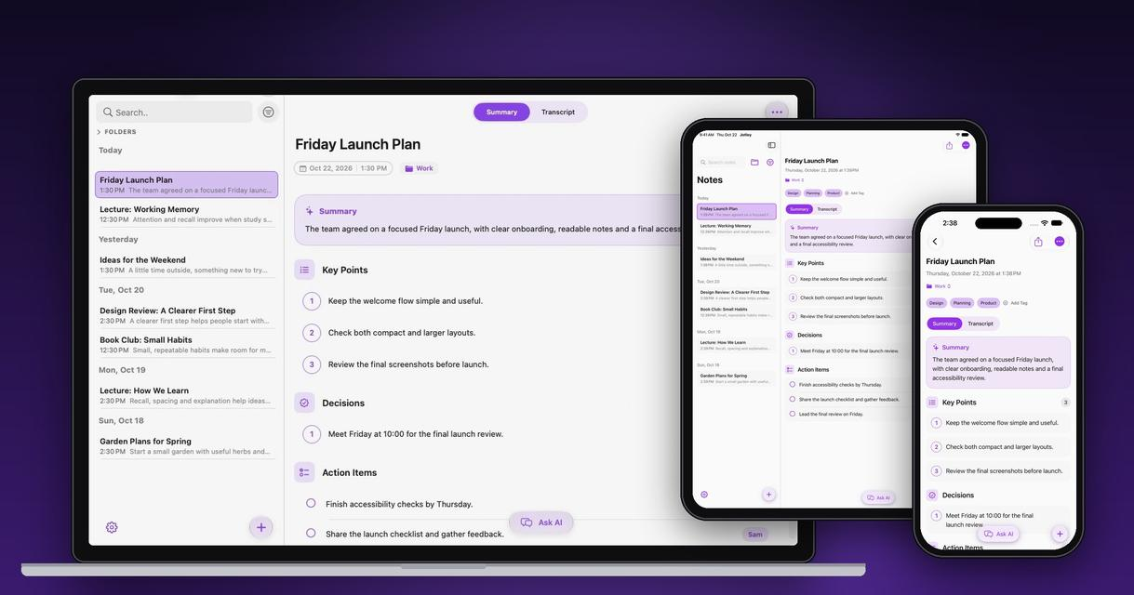  Jotley Fig. 2  Private AI notes for Mac, iPhone and iPad. Transcribes speech live, then summarizes and answers questions on the device with Apple Intelligence.  Full product: design, app, release, marketing, website.  Swift, SwiftUI, Apple Intelligence, iCloud  jotley.ai |  | 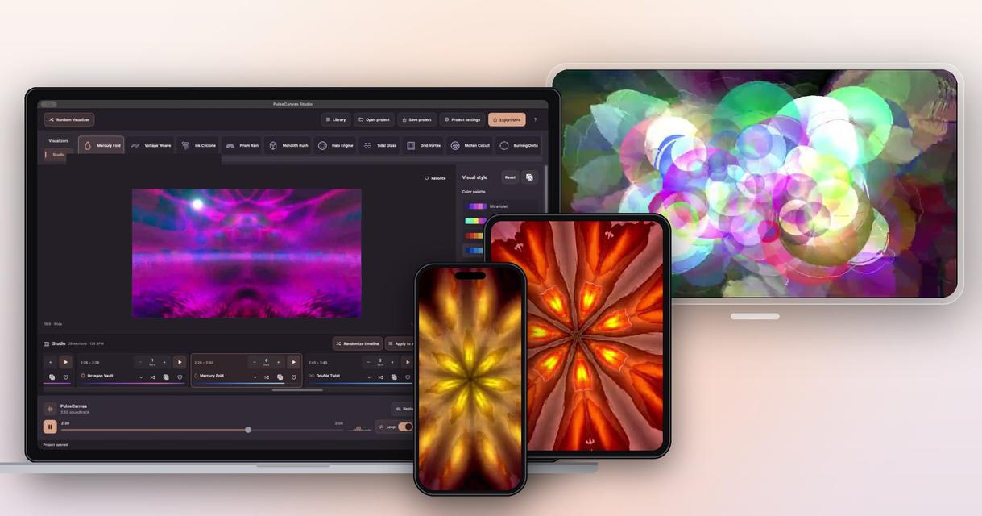  PulseCanvas Studio Fig. 3  Music visualizer and video maker for Mac, iPhone, iPad and Apple Vision Pro. Finds the beat, splits the song into sections and plays native visualizers and MilkDrop effects.  Full product: design, app, release, marketing, website.  Swift, SwiftUI, Metal, export up to 4K at 60 fps  pulsecanvas.si

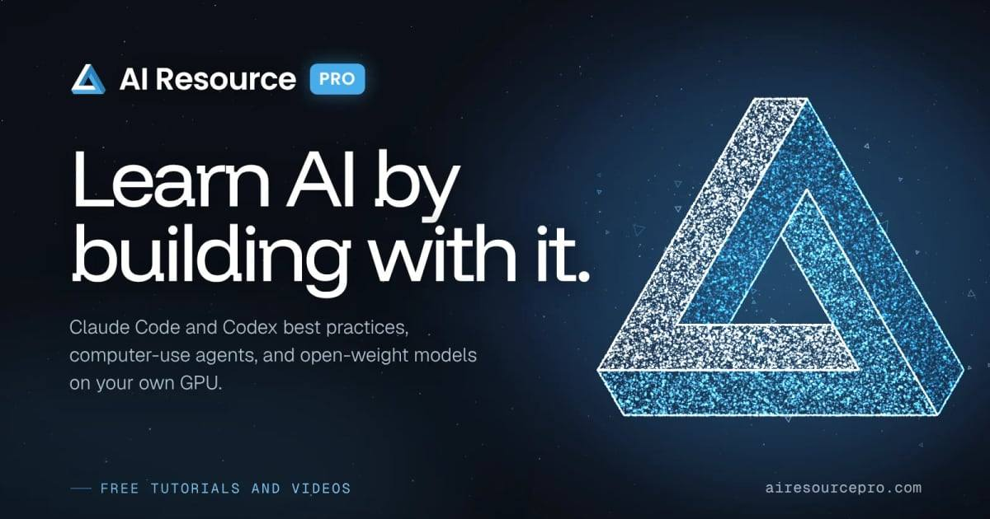  AI Resource Pro Fig. 4  Free tutorials and videos for learning AI by building with it: Claude Code and Codex best practices, computer-use agents and open-weight models on your own GPU.  airesourcepro.com  youtube.com/@AIResourcePro1 |  | 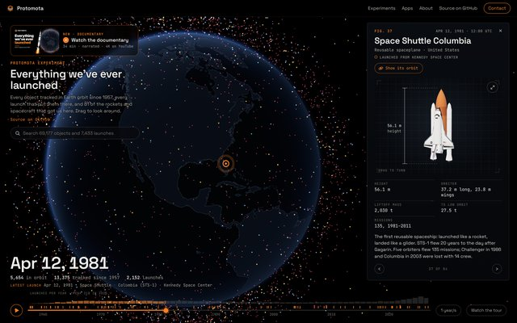  Everything we've launched Fig. 5  Interactive 3D simulation of every object tracked in Earth orbit since Sputnik, appearing launch by launch on a 3D Earth. Stop at milestone ships, search any object, and see how much of it is junk.  protomota.com/experiments |  | 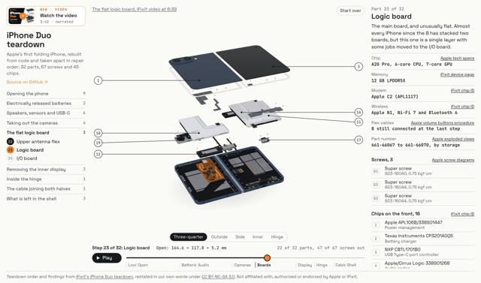  iPhone Duo teardown Fig. 6  A folding iPhone rebuilt in code. Take it apart in repair order and tap any part to see where the numbers came from.  protomota.com/experiments

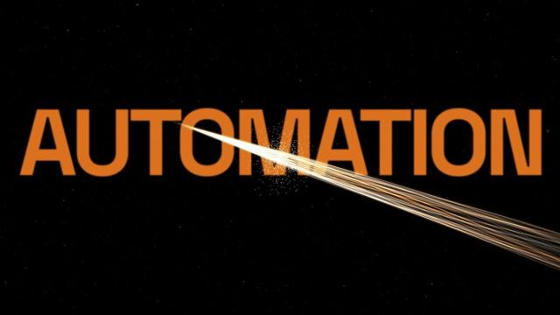  AI video and motion Fig. 7  Clips, short films, titles and visuals that move to music.  protomota.com/motion  youtube.com/@protomota |  | 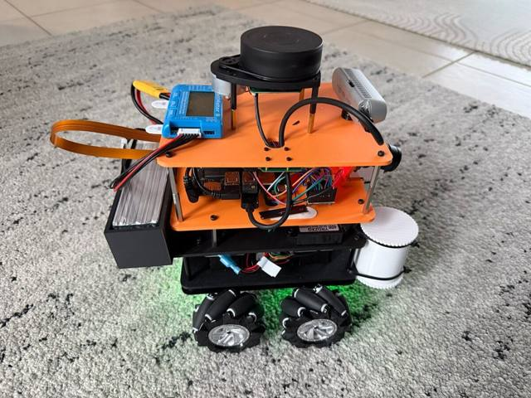  Project Ogre Fig. 8  Mecanum-drive robot on a Jetson Orin Nano with SLAM and Nav2 autonomous navigation, trained in Isaac Lab.  newsletter.protomota.com |  | 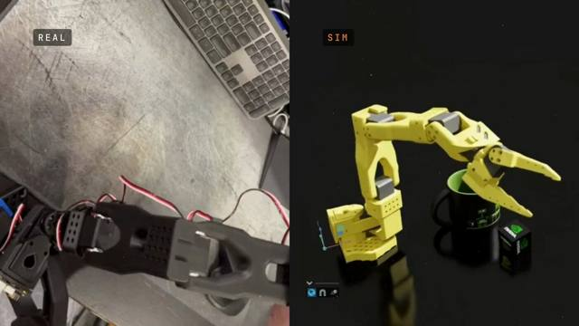  SO-ARM 101 digital twin Fig. 9  A leader arm drives a 6-axis arm in Isaac Sim in real time.  Build log |  | 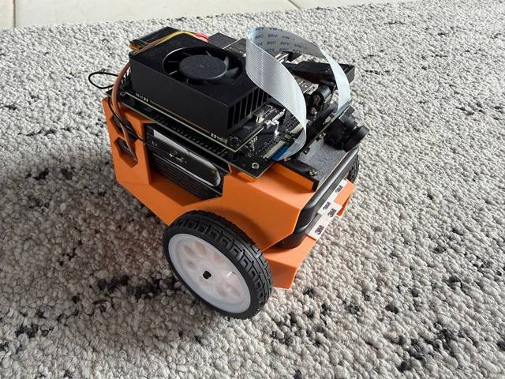  JetBot Orin Fig. 10  The NVIDIA JetBot, rebuilt for the Jetson Orin Nano with a custom chassis.  Build log

More work protomota.com github.com/protomota newsletter.protomota.com x.com/protomotalab

